Patient Vital Signs Analysis

Description:

The project follows a clean, modular, and scalable directory structure to separate concerns such as data, models, streaming logic, backend services, and UI components.

This ensures maintainability, clarity, and scalability for future development.

Folder Structure:
PythonProject/
├──. venv/ # Virtual environment
├── data/ # CSV datasets
│ └── patient_vitals.csv
├── scripts/ # Python scripts
│ ├── create_vitals_csv.py
│ └── validate_vitals.py
├── models/ # Placeholder for model files
├── streaming/ # Placeholder for streaming logic
├── backend/ # Backend services if needed
└── README.md
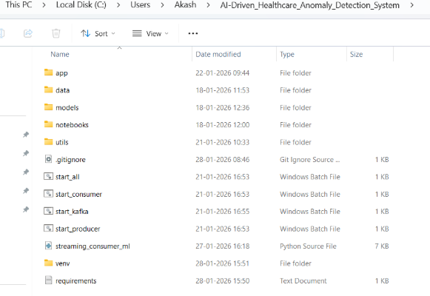
Outcome of Milestone 1
- Python environment configured successfully
  - Virtual environment. venv created in PyCharm
  - Python interpreter verified

- All dependencies installed
  - Pandas installed successfully in project virtual environment
  - Verified using pip show pandas
- Dataset validated
  - patient_vitals.csv loaded successfully

  - Columns present: 'Timestamp', 'Heart_Rate', 'Resp_Rate', 'Temp_C', 'SpO2', 'BP_Sys', 'BP_Dia', 'HRV'

  - Missing values: 0 in all columns
  - Out-of-range entries: 0 for all vital signs
Project structure finalized:
  - Clear separation of scripts, data, models, backend logic
Dataset Preview:

Timestamp | Heart_Rate | Resp_Rate | Temp_C | SpO2 | BP_Sys | BP_Dia | HRV
2026-03-08 00:00 | 78 | 16 | 36.7 | 97 | 120 | 80 | 45
2026-03-08 01:00 | 85 | 18 | 36.9 | 96 | 118 | 79 | 48
2026-03-08 02:00 | 90 | 17 | 37.1 | 95 | 122 | 82 | 42
2026-03-08 03:00 | 88 | 15 | 36.8 | 98 | 119 | 80 | 44
2026-03-08 04:00 | 82 | 16 | 36.5 | 97 | 121 | 81 | 46

Dataset Validation Summary

- Dataset Shape & Columns: 5 rows × 8 columns, all required features (Timestamp, Heart_Rate, Resp_Rate, Temp_C, SpO2, BP_Sys, BP_Dia, HRV) are present.

- Missing Values: 0 missing values detected in any column.

- Out-of-Range Values: All vital signs are within normal physiological ranges.

- Conclusion: The dataset is complete, clean, and ready for analysis or modelling.

